**Project Design Phase-II**

**Technology Stack (Architecture & Stack)**

|  |  |
| --- | --- |
| Date | 18 April 2025 |
| Team ID | SWTID1743603827 |
| Project Name | Book - Store |
| Maximum Marks | 4 Marks |

**Technical Architecture:**

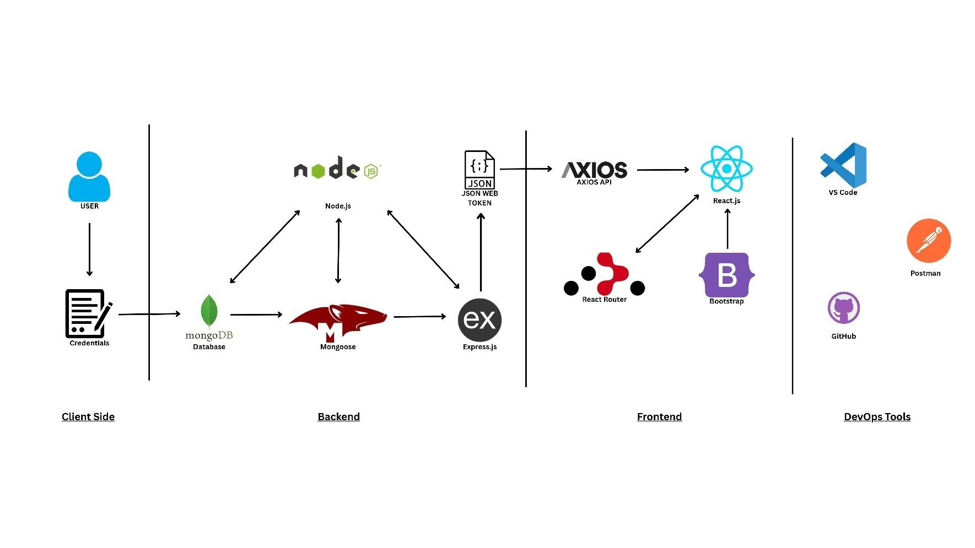

# Table 1: Component Table

|  |  |  |  |
| --- | --- | --- | --- |
| **S.no** | **Component** | **Description** | **Technology** |
| 1. | User Interface | Web UI to interact with the system | HTML, CSS, JavaScript, React.js |
| 2. | Application Logic-1 | Logic for user authentication | Node.js, Express.js |
| 3. | Application Logic-2 | Logic for user registration | Node.js, Express.js, JWT |
| 4. | Application Logic-3 | Routing and form handling | React Router, Axios |
| 5. | Database | Stores user credentials and data | MongoDB |
| 6. | Cloud Database | MongoDB used via cloud service like MongoDB Atlas | MongoDB Atlas. |
| 7. | External API-1 | Used for HTTP calls between frontend and backend | Axios API |

# Table 2: Architecture & Design Characteristics

|  |  |  |  |
| --- | --- | --- | --- |
| **S.no** | **Characteristics** | **Description** | **Technology** |
| 1. | Open-Source Frameworks | All major frameworks used are open-source | Node.js, Express.js, React.js,  MongoDB |
| 2. | Security Implementations | Token-based authentication & hashed credentials | JWT, Bcrypt, HTTPS, Helmet |
| 3. | Scalable Architecture | 3-tier architecture with separation of concerns | Frontend-Backend-DB |
| 4. | Performance | Optimized API calls and component-based UI rendering | Axios, React Virtual DOM, Caching |